Imperitive style to store names of employees in a list and display them
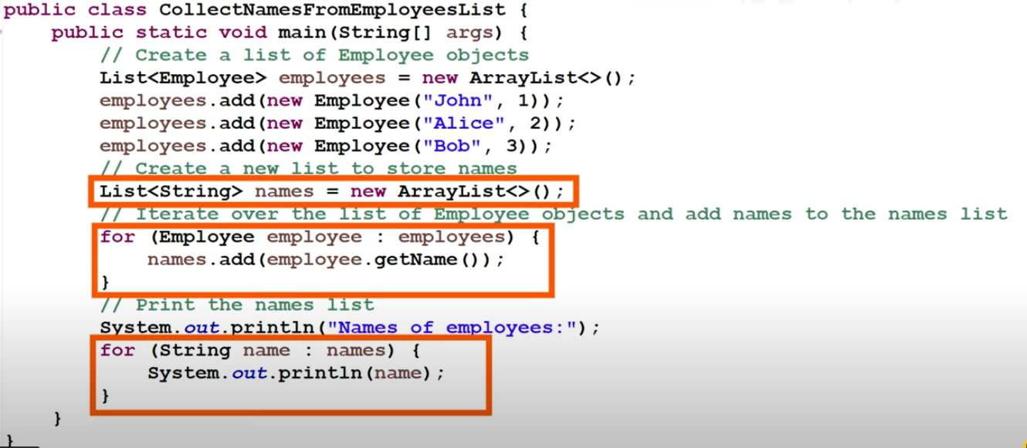

Ways of creating a stream
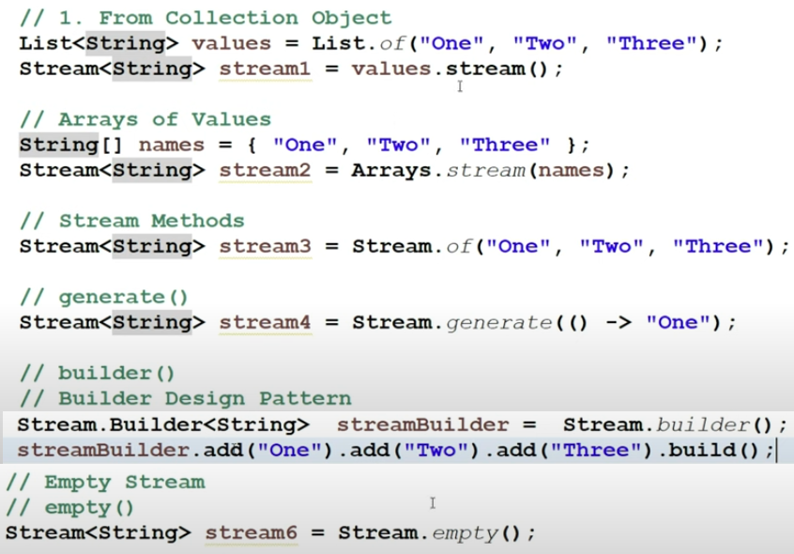

1. WE CAN CHAIN ANY NUMBER OF INTERMEDIATE OPERATIONS(IO) known as STREAM PIPELINE
2. EACH IO WILL RETURN A NEW STREAM
3. EACH IO IS APPLIED ONCE PER ELEMENT
4. IO ARE LAZY THEY ARE EXECUTED ONLY WHEN A TERMINAL OPERATION IS INVOKED

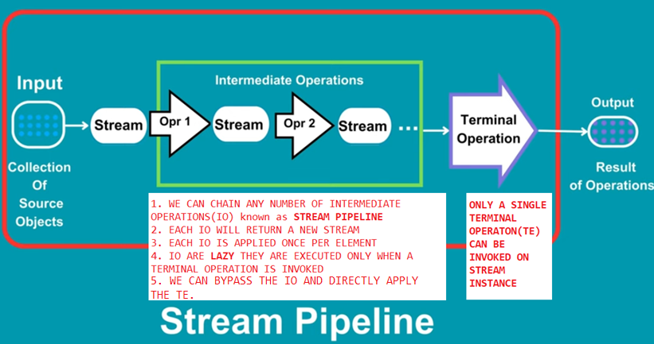
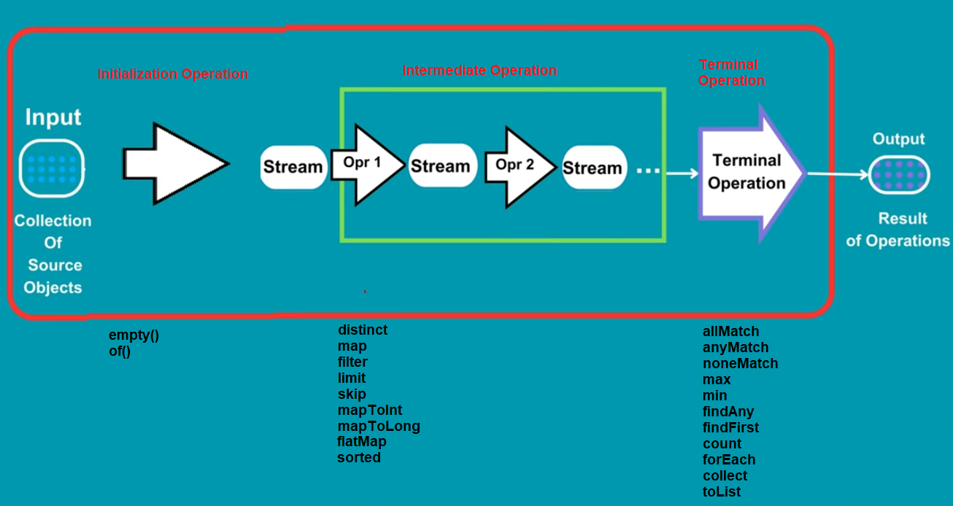
get()
reduce()
Stream object should not be used more than once,else it will throw IllegalStateException
Int arr[]={1,2,3,45}
List<Integer> nonPrimitiveIntArray = Arrays.stream(arr).boxed().collect(Collectors.asList);

Java 16 onwards replace
.collect(Collectors.toList());
with
.toList()

Limit(3)
Skip(3)

joining()
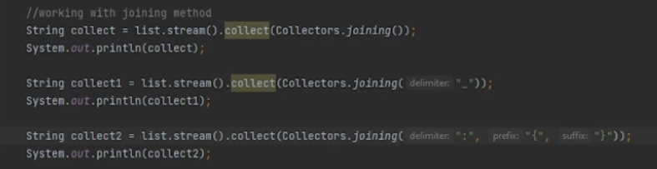
Output
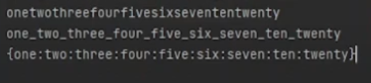

partitioningBy

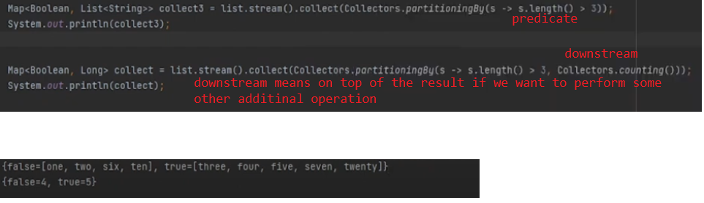

GroupingBy : // partitionBy uses Predicate, groupingBy uses function
